**Tutorial 03**

Here we learn how to make some simple Collectables. It is really easy, coding is not that hard but very important to have an idea of how to do because we’ll be using collectables a lot.

* As usual you need to make a 3D object cube and scale it as it looks like a Ground. And rename it as Ground. If you wish you can add a material to that as well.
* Next you have to create a 3D object Cylinder and scale it down as it looks like a Coin. And rename it as Coin. Here I have chosen the most obvious shape of a collectable, Coin. Why not give a material to that as well.
* Now add a C sharp script to the Object Coin (Add a Component > C sharp script) and rename it as Rotator. Double click the script and open it from MonoDevelop or Visual Studio.

*Now the coding part…*

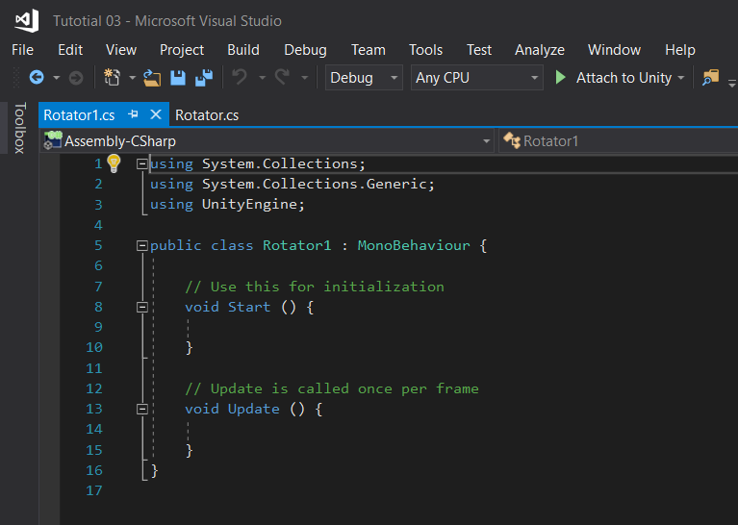

When you open your Rotator Script it will look like this. I’m using visual studio.

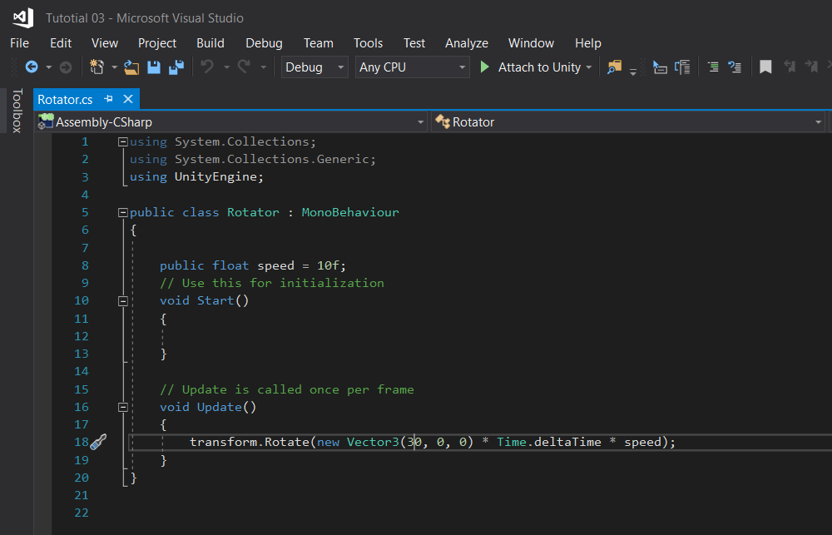

This is basically the full script that you will be needing. As I said it is very easy.

First, I have added a Rotation Speed and made it public so I can adjust speed from Unity.

You can skip the Start function because we won’t be using it, and move to the Update function.

Here we rotate the “x” axis by adding a number, and multiply it by each frame using Time.deltaTime again multiply it with speed.

There you go, now if save it (ctrl + S) and go to Unity and press Play. Your Coin starts to rotate now.

If you want to create more, make the coin a prefab by dragging it from the Hierarchy menu to Project menu.

Enjoy!

Lakshitha Abeyrathna